**Prerequisite:** install visual studio 2015

**Description:** EI is part of ALM, and add some functions to ALM client side for interaction with user. You can see here, here is the client side in Settings, there SAP tools all functions of EI is in SAP tools

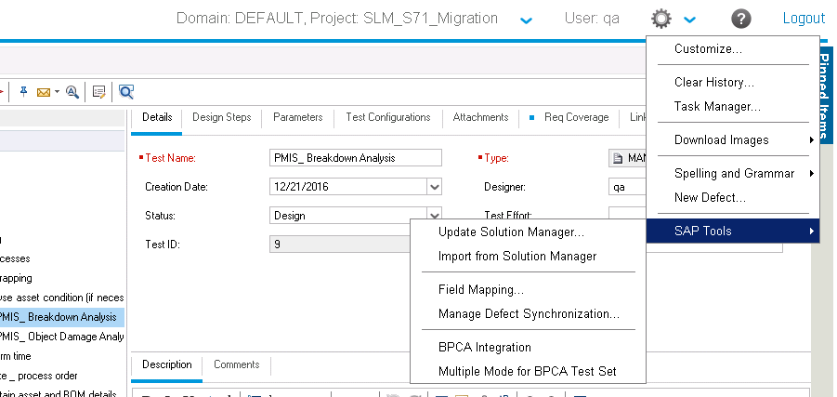

**Code:** Client side code is in path: \ei\assets\Backend\Client, you can see the following snapshot

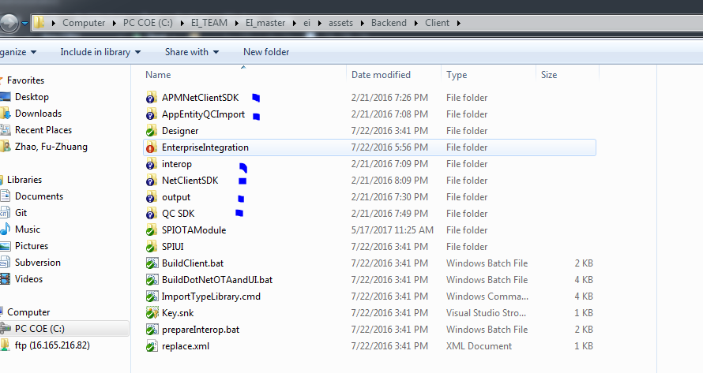

**Reference:** APMNetClientSDK, AppEntityQCImport, interop, NetClientSDK, output, QC_SDK from

\\mydastr01.hpeswlab.net\products\TestDirector\ALMDev\ALM1255\ALM1255\Archives\12.55.2529.0.0\Development_StaticData

**Visual Studio Build:** when you import Enterprise Integration to VisualStudio2015, you need to configure two project's reference and then to build it until two project build pass

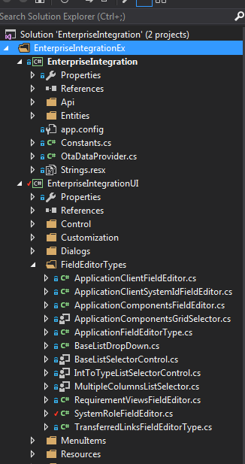

**Debug**: <http://localhost:8080/qcbin/start_a.jsp?debugClient=true> you can do attach process add ALM-Client.exe process to this debug.